MAIN PAGE

SIDING & SOFFIT
Industrial / Residential / Commercial
Enhance the aesthetic and functional appeal of your industrial, residential, or commercial property with our high-quality siding solutions. At Cladcan, we offer a wide range of siding materials designed to meet diverse architectural needs and performance requirements. Choose from an impressive selection of solid colors and realistic wood-look finishes to achieve the perfect visual effect for your project. Our products ensure durability, energy efficiency, and exceptional visual appeal, making them ideal for any building project.
Find the ideal match for your project with our impressive array of offerings!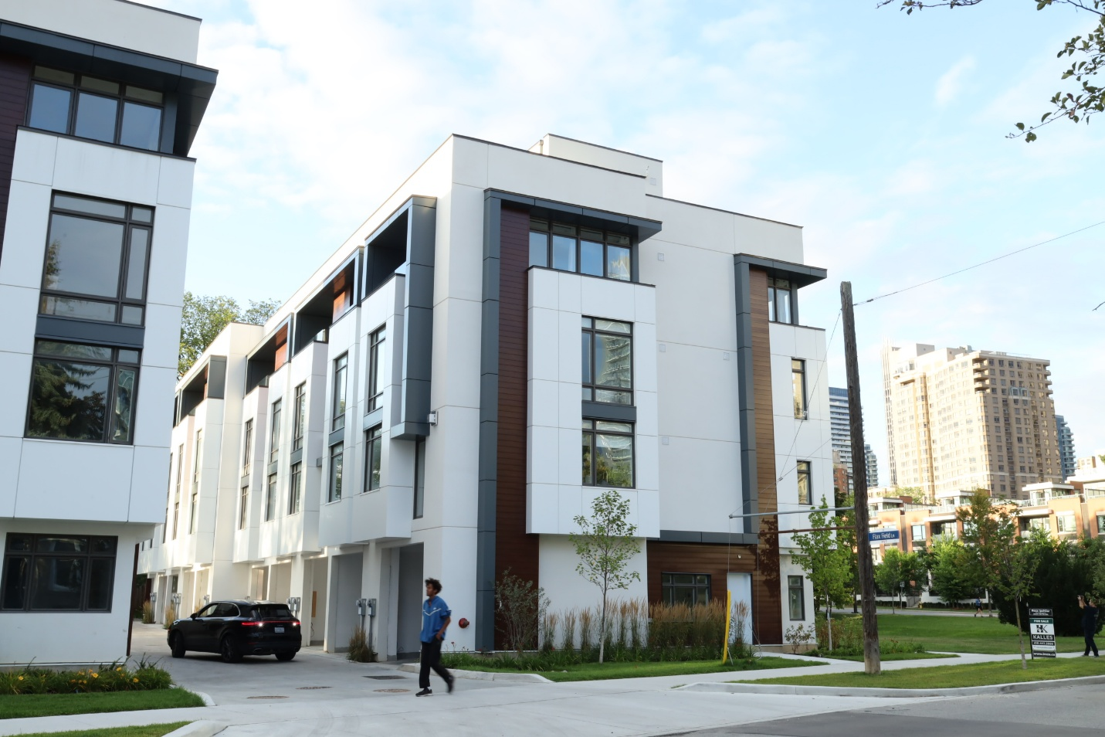

SIDING & SOFFIT MENU ICON (PREVIEW)

Aluminum Siding & Soffit
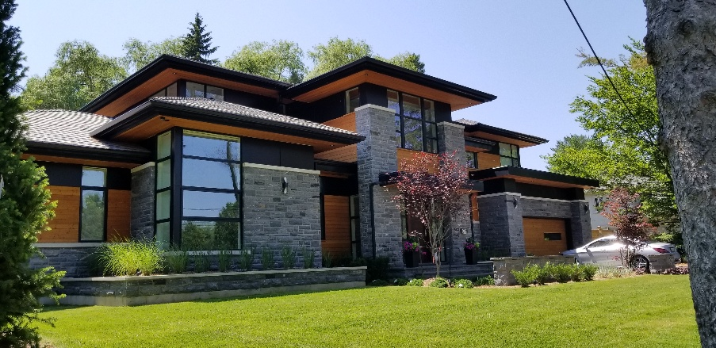
Our premium aluminum siding & soffit solutions are meticulously crafted to elevate both the aesthetic allure and structural fortitude of your project, seamlessly marrying elegance with practicality. (Learn More- Expand)
Expanded …Our aluminum siding & soffit boasts an extensive palette of colors and textures, providing robust protection against the elements while enhancing your build’s visual charm. Delve into our Aluminum panel choices to uncover how our cutting-edge siding options that can redefine your living & working spaces with enduring sophistication and effortless upkeep.
Curious about the advantages of aluminum siding? Visit our blog to explore the compelling reasons why this choice stands out for homeowners seeking durability and style.
Speak with an Expert
Get personalized advice and expert guidance to achieve your project goals with confidence.

1- LONGBOARD MENU ICON (PREVIEW)

Longboard Premium Siding & Soffit
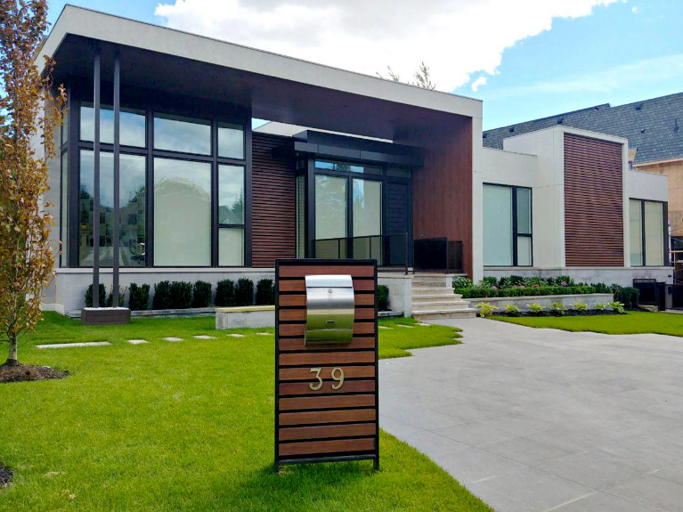
The Longboard Tongue & Groove aluminum plank system offers an elegant and adaptable cladding and soffit solution. (Learn More / Expand)

- 1 LONGBOARD PAGE (EXPANDED)
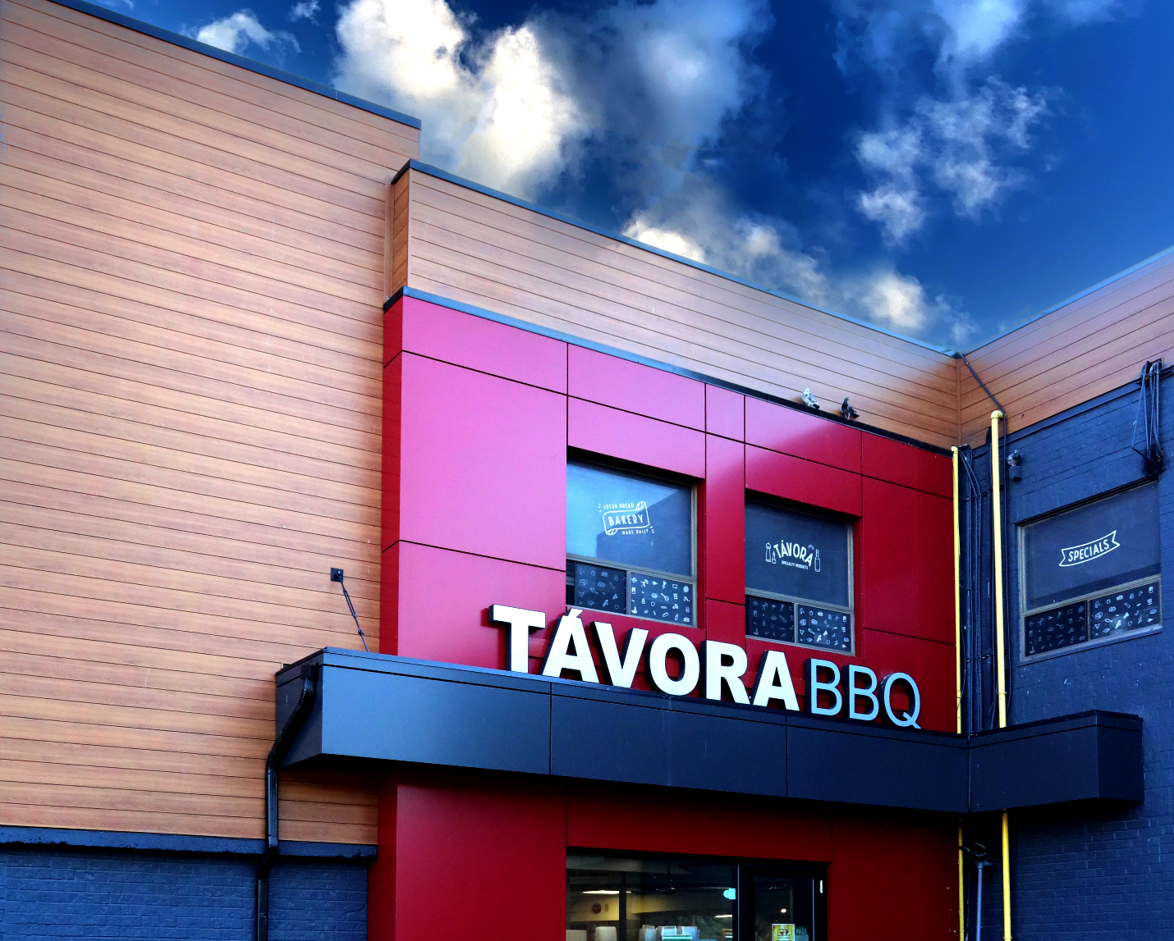
Expanded … The Longboard Tongue & Groove aluminum plank system offers an elegant and adaptable cladding and soffit solution. Crafted from 100% extruded architectural aluminum, it is lightweight, non-combustible, and highly resistant to weather conditions, ensuring long-lasting performance.

Designed to enhance both interior and exterior applications, this cladding system seamlessly complements projects of any scale. Available in 24-foot lengths, it can be easily customized either in a pre-fabrication facility or directly on-site to meet specific project requirements. For added design flexibility, planks can be installed in either a horizontal or vertical orientation.
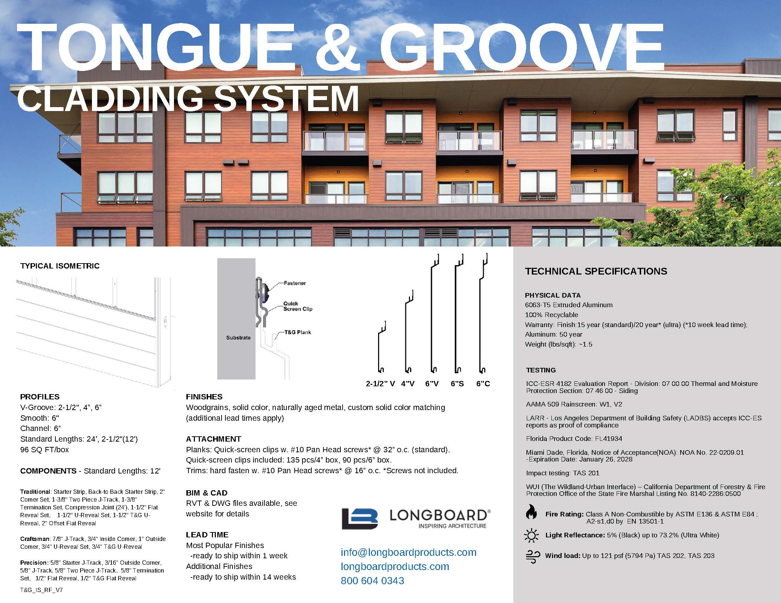

Profile Collection
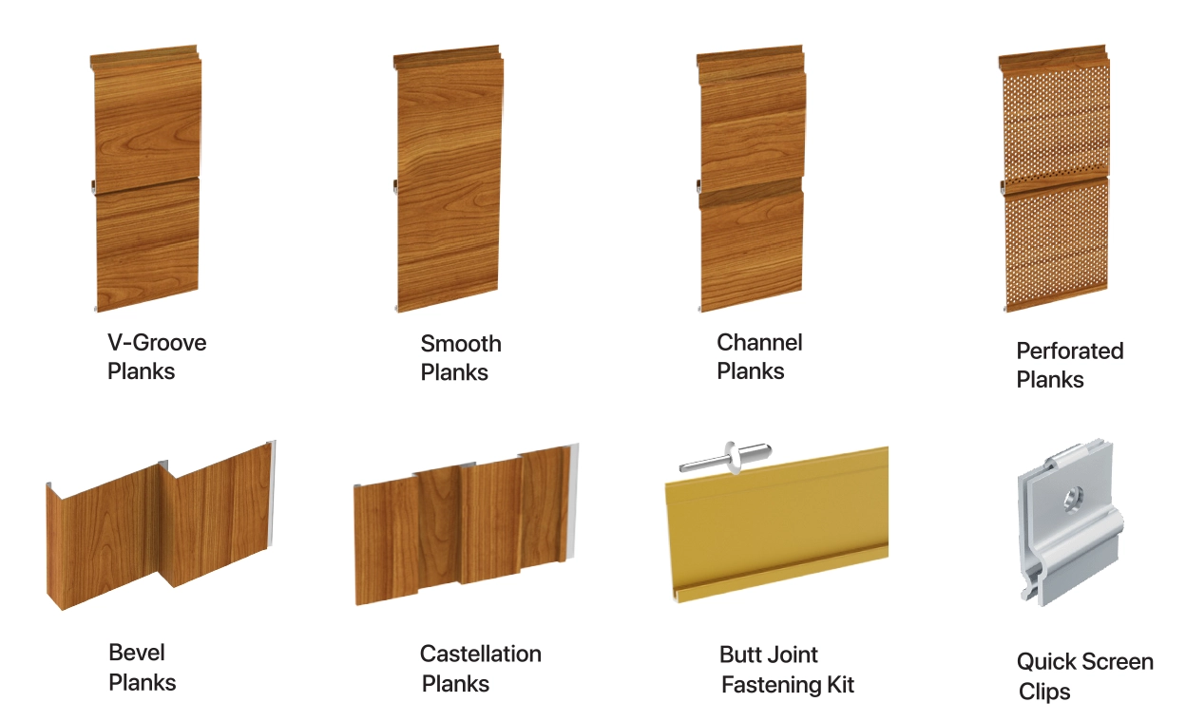

Trim Components
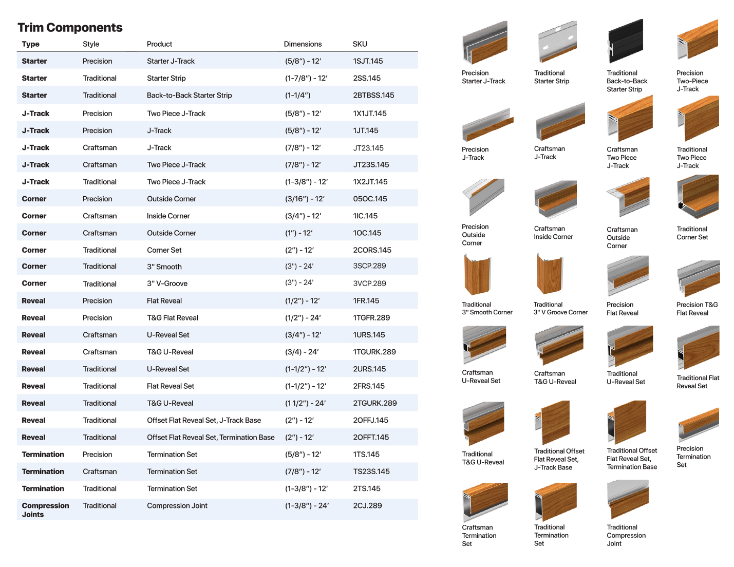

Superior Finishes for Lasting Performance
Our cladding products and systems are coated with premium AAMA 2604/2605-certified powder finishes, ensuring exceptional durability and longevity. Designed to replicate the natural beauty of materials such as stone, brick, wood, terracotta, and aged metals, these finishes deliver both aesthetic appeal and robust performance.
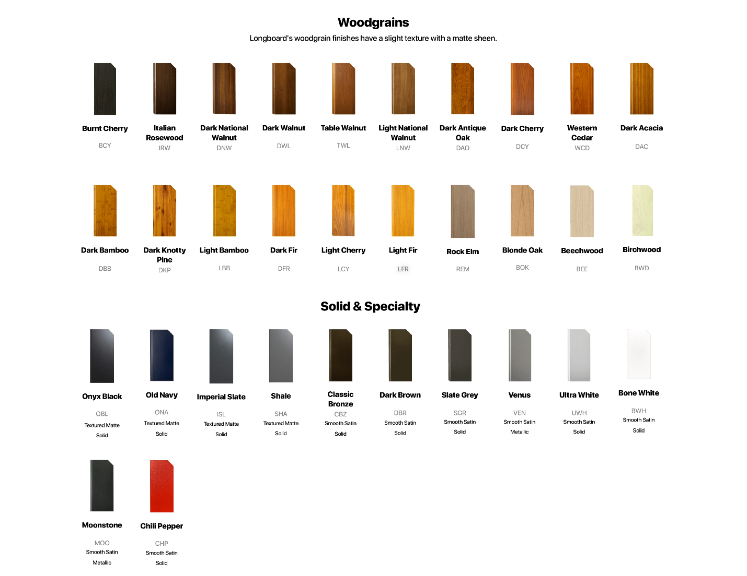
Engineered for superior resilience, our high-performance coatings provide outstanding protection against wear and environmental factors. We are committed to sustainability, utilizing advanced pre-treatment processes that meet stringent industry standards—free from chromates, cyanides, phosphates, and other EPA/OSHA-regulated metals.

Speak with an Expert
Get personalized advice and expert guidance to achieve your project goals with confidence.

